How to Use Lab Link HF

I. Preparing to Use Lab Link HF

Before you can use Lab Link HF you will need to follow the first three steps in the How to Import Data help document. You will need to create a job in Lab Link, import a roster, and print camera cards. The final step will be to export the data file for HF.

From the main Lab Link screen right-click on the order you wish to export a data file from. Select Tools, and then Export for Lab Link HF.

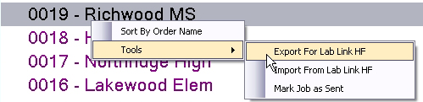

Save this file to your desktop. If you will be using Lab Link HF on a separate computer, save the file to a Flash Drive, or email the file to yourself to get the file to the computer where Lab Link HF will be used.

Open Lab Link HF. Navigate to the location of the export file. Make sure the name of this file matches your job name from Lab Link. It is important not to import an incorrect export file. Lab Link HF will process this file and will open.

II. How to use Lab Link HF

If this is your first time using Lab Link HF it must be configured. All of these settings will be remembered by Lab Link HF so these steps will not need to be repeated. Select the Config drop down from the menu bar and choose Set Hot Folder.

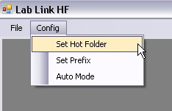

You will need to tell Lab Link HF the location of the hot folder where you will be shooting your images. Next, choose Set Prefix. Here you will want to designate camera number or photographer’s initials. This will be added to the beginning of the camera filename. The next option from the Config drop down is Auto Mode. This mode allows for a faster workflow and will be discussed later in section III.

Take your first picture. It should display on screen within a second. If the rotation needs to be adjusted choose Left or Right from the drop down below the image and beside where it says Auto-Rotation. Right-click on your image. A red X should appear to mark it for deletion. Below the image press the Delete button. Reshoot the image and now the rotation will be correct. This Auto-Rotation will be remembered by Lab Link and will not need to be done each time. You should also see crop bars (green and blue lines) and head and chin guides (red lines) on your image. These are here to encourage consistent shooting and show how the 8x10 (the green line) and the 5x7 (the blue line) will crop in to the image. The head and chin guides can be adjusted in Lab Link and exported in to Lab Link HF if you choose to customize their heights. These guides can be turned on and off with the buttons below the image.

Click on the image. It should be outlined in blue which indicates it is selected and ready to match to a data record. It will also be outlined in red indicating that a package can be added to the image. Only one image can be focused but multiple images can be selected. This means that you can shoot multiple images, select them all, and match them to one data record, but you can only key a package on one of those images at a time. Each image is able to have a different package even if multiple images are attached to the same data record.

In the box below the image type a SubjectID number from one of your camera cards and hit the enter key or search button. You can also use a barcode scanner to read the SubjectID number from the camera card. If you do not know the SubjectID number change the drop down to Lastname, Firstname and search using the subject’s Lastname. Don’t forget to change the drop down back to SubjectID before typing or scanning the next card. The record should display below. If nothing needs to change with the data record press the Save button above the record. If the button is not active make sure the image is selected and now it can be saved. The image and record will clear preparing the way for the next shot. If the data record does need to be edited just click and type in the correct column before matching. You can always correct data once the job is back in Lab Link as well.

If you do not have a card for an image you can use the new record button to create a new data record. Just press the New Record button and type any data in to the correct columns and then save to the selected image.

Keying a package on an image is done the same as it is in Lab Link. With the image focused, select a Package Set, and then a package, and press the Add button. Remember, only one image can have a package ordered on it at a time.

III. Using Auto Mode

From the Config drop down box choose Auto Mode. This will hide the Delete button below the image. In this mode you can still delete an image but instead of it deleting for good, it will just be placed in your deleted folder in Lab Link in case it is needed at a later time.

The idea behind this mode is that you should be able to scan a camera card, take a picture, and scan the next camera card which will result in automatically saving that image to the previous scanned data record. Now take the next picture and when you scan the next card that picture will save to the previous record. This should create a very fast workflow. If you are adding packages you will need to click the image in order to add the package. You must make sure to click back in the SubjectID box before scanning the next card in order for it to read accurately. When you take the final image you should just save this image to the record using the Save button. If the button is not active, click the image.

At any time you can turn off Auto Mode from the Config menu.

IV. Finishing with Lab Link HF

Once all images have been matched select File from the menu bar. Choose Export Data. This will save a folder to your desktop containing the export file and images that you will use to import back in to Lab Link. Save this folder to your Flash Drive so that you can get the images and data to the computer with Lab Link. Repeat these steps for any computer used for the same shoot. All of these Lab Link HF Export folders should be copied in to the same folder on the computer that has Lab Link. Lab Link will compile all of the export folders together automatically and import them in to the job.

V. Import back in to Lab Link

From Lab Link’s main screen locate your job. Right-click on the job and from the Tools menu select Import From Lab Link HF. Browse to the folder containing your Lab Link HF Export folder(s).

The Import From Lab Link HF Form will open. You should see your export folder(s) listed. If you do not see the correct folders listed click the X in the top right corner and repeat the import steps making sure to locate the parent folder that contains the correct Lab Link HF export folder(s) for this job.

This is how the window should appear:

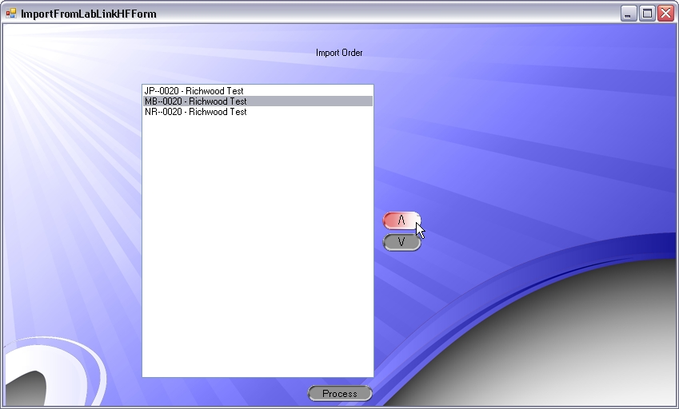

You can click on the folders listed in the window and use the arrows to the right to shift a folder up or down. The order of the folders in this window is the order in which they will be imported in to the job.

When you are happy with the order of these folders, click the Process button. If any changes were made to a data record in Lab Link HF or if Lab Link finds any conflicting information, the SubjectIDs will be displayed in the next window. Click on the first SubjectID. Below the SubjectID box will display the data records associated with this ID. The first line is the data as imported originally. After that Lab Link will list the modified records from each camera that used this SubjectID. In most cases this will just be one camera as in this example:

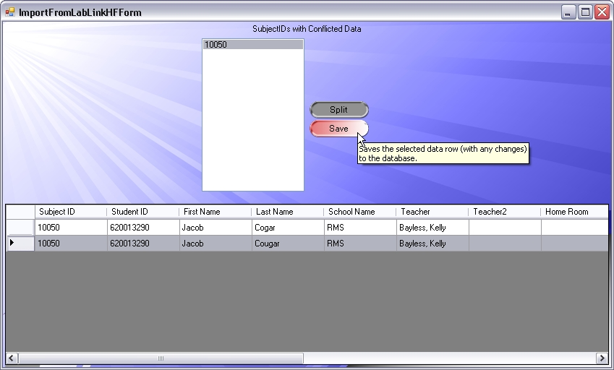

Here you can see we just changed the Lastname of the subject. We would select this second row and click the save button. Lab Link will take this modified record and replace the one currently in the job. Continue this for any remaining SubjectIDs.

The Split button is used less often and involves taking the data record and image and giving it a new SubjectID.

When you have finished with all SubjectIDs the import will be complete.

If you are aware of any additional changes that need to be made to matched images please refer to the How to Import Data help document section V. Match Your Images to further adjust the matching.

When matching is complete open the Build screen and Lab Link will create thumbnails for your job.

